LittleBytes

Design

-Project: User Interface Design

-Tool: Django

Using the Django framework, our team has developed a simple to use UI to help the user better navigate, and control various aspects of their store. Django came with many features ideal to creating an easy to use UI that paired well with the tasks at hand.

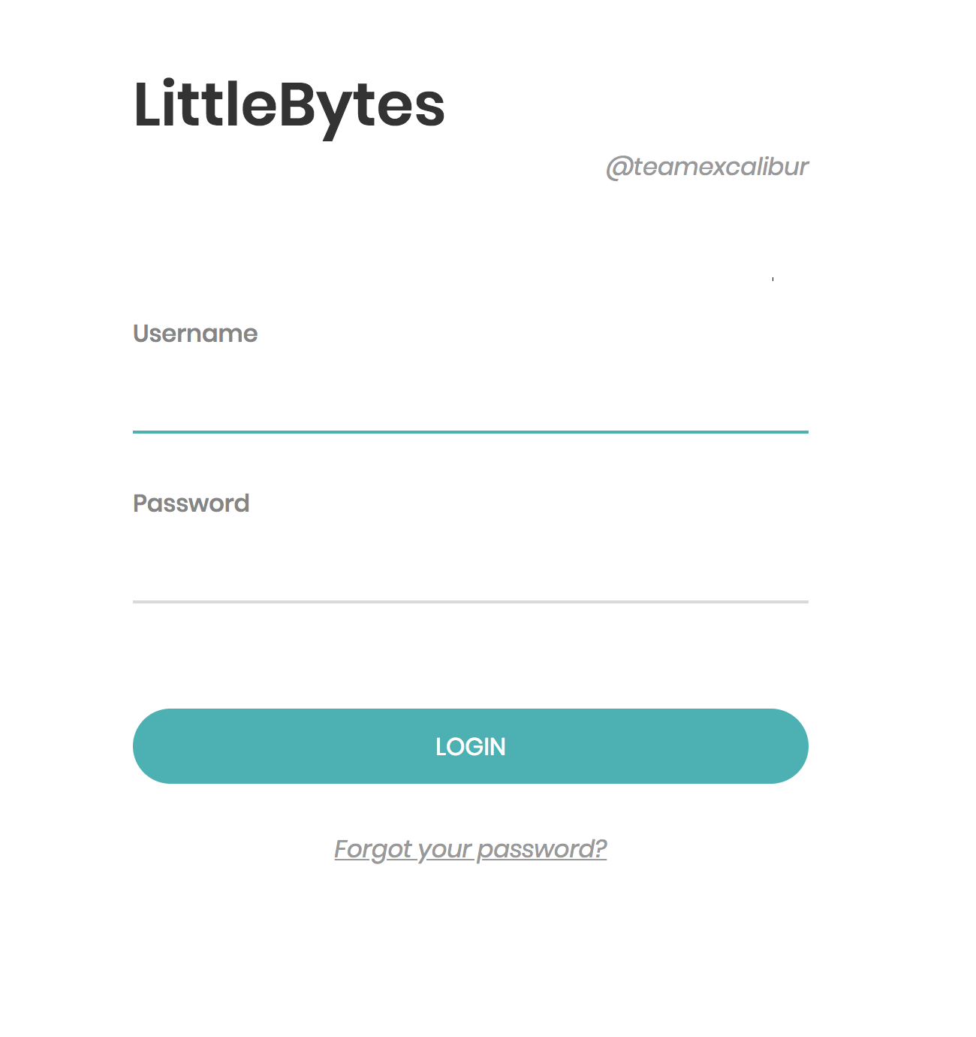

A Django powered log in screen to better manage who and when a user gets access to the system. The system will allow access once an already registered user that entered their “Username”, and “Password”. If a user were to forget their password, a password recovery system has been put into place simplly click the “Forgot your password” under the login.

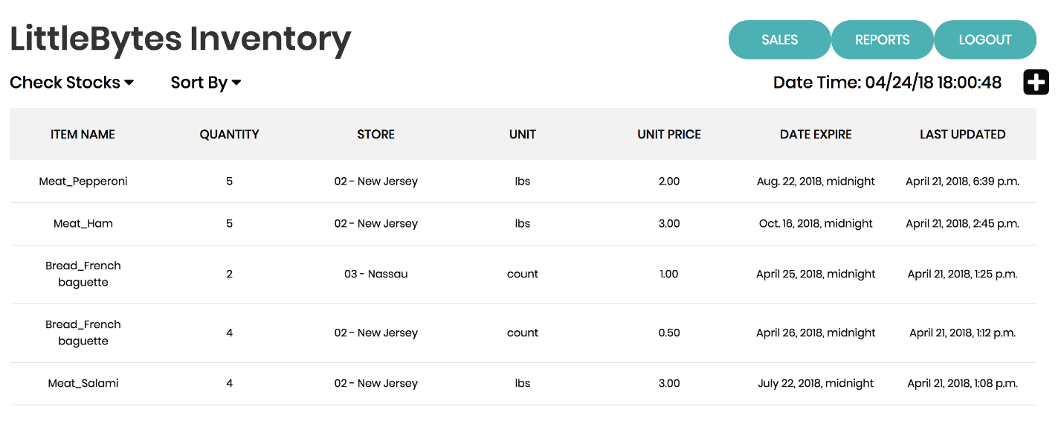

Here we have the LittleBytes Inventory which tracks how many items you have available in all LittleBytes stores. The Inventory screen will provide information in the following fields “Item Name”, “Quantity”, “Store”, “Unit”, and “Unit Price”, to help users know exactly what they are looking for. Any items that are perishables can also be tracked with an expiration date displayed on the right hand side labeled “Date Expire”. The System will also keep track of when an item were last updated in the “Last Update” tab.

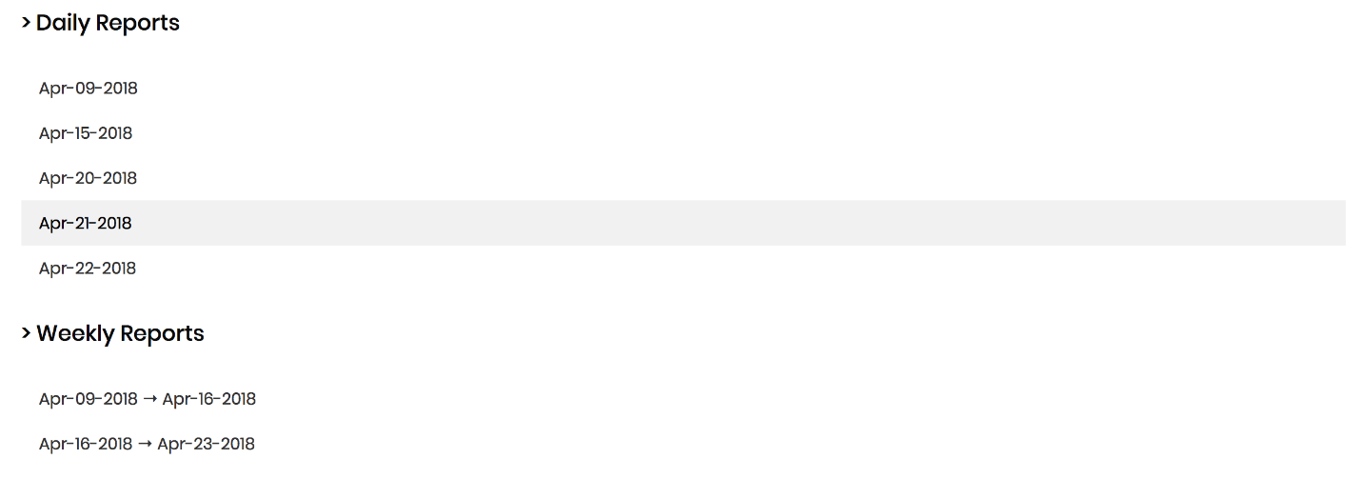

The system will keep track of sales reports in two different formats, “Daily Reports”, and “Weekly Reports”. By selecting a date from the list, the system will deliver to the user an overall report of what his/her store is selling.

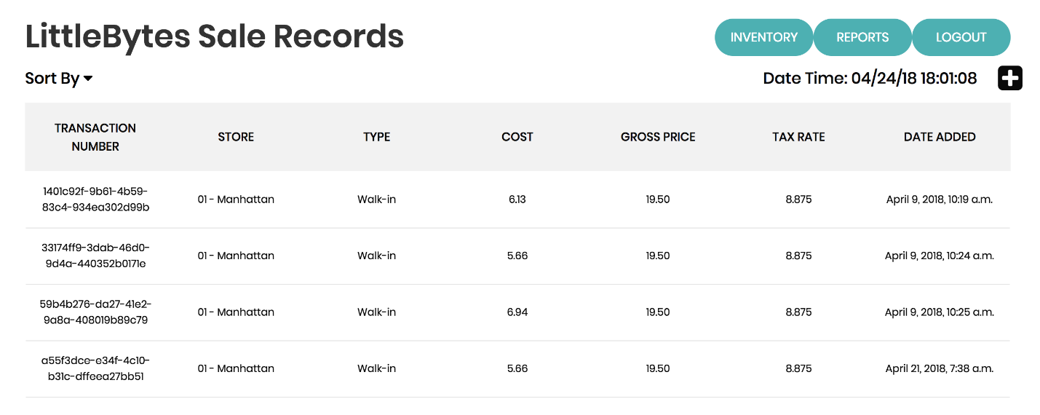

The sales records are updated per store sale, all products will have a “Transaction Number”, and track various forms of useful information. The information displayed is as follows, “Store”, “Type”, “Cost”, “Gross Price”, and “Tax Rate”, providing the information necessary for each, and all transactions. A “Dates Added” tab is also displayed to track when these transactions happened.